<https://www.investopedia.com/terms/g/great-recession.asp>

Recovery from the Great Recession

The aggressive [monetary policies](https://www.investopedia.com/terms/m/monetarypolicy.asp) of the Federal Reserve and other central banks in reaction to the Great Recession, although not without criticism, are widely

For example, the Fed lowered a key interest rate to nearly zero to promote liquidity and, in an unprecedented move, provided banks with a staggering $7.7 trillion of emergency loans, according to The Week, in a policy known as [quantitative easing](https://www.investopedia.com/terms/q/quantitative-easing.asp). Along with the inundation of liquidity by the Fed, the U.S. Federal government embarked on a massive program of [fiscal policy](https://www.investopedia.com/fiscal-policy-4689796) to try to stimulate the economy in the form of the $787 billion in deficit spending under the American Recovery and Reinvestment Act, according to the Congressional Budget Office.

In other words the Fed gave banks $7.7 trillion of emergency loans so the banks have actually loans to distribute and thus liquidity increases. Consequently, although we are expecting the liquidity factors to drop massively over the out of sample period that we include in part c, this may not be the case. Of course it shouldn’t be the same liquidity factors you have before 2008(technically 2007 because the Great Recession takes place from 2007 to 2009) since at that point the market was booming and liquidity was at its peak due to the fact that banks gave loans without many restrictions and people traded with “ease”. This was in fact a reason of the market collapse of 2008 because the lendees (the people who received the loans) were evidently not capable of repaying their mortgage loans. (not many details on how the housing market crisis was created since that’s not what we are interested in).

Some in sample dates that should be crucial to investigate:

1929: Black Tuesday (August)

1987: Black Monday (October)

1999-2001: Dot-com bubble ( Burst of bubble lasted from March 11 2000 to October 9 2002)

Extra question here: do we have information on the types of stocks in our portfolios are they considered to be tech stocks or doesn’t make any difference since tech stocks were not the only stocks that were affected

2008: Housing market crash

The Great Recession lasted from 2007 to 2009

Intuition: After 2009 market was stabilized although now our liquidity factors should be lower since banks were more restrictive on their loan policies hence not many loans were available and hence trade is not done at such an ease that was before 2008.

<https://faculty.chicagobooth.edu/lubos.pastor/research/fig_aggliq1.pdf> liquidity graph Pastor

<https://faculty.chicagobooth.edu/lubos.pastor/research/>

In our data we consider aggregate liquidity which indicates how easily financial transactions can be made in the market or in our case, since we consider stocks, we have a measure of how easily a stock/asset can be traded.

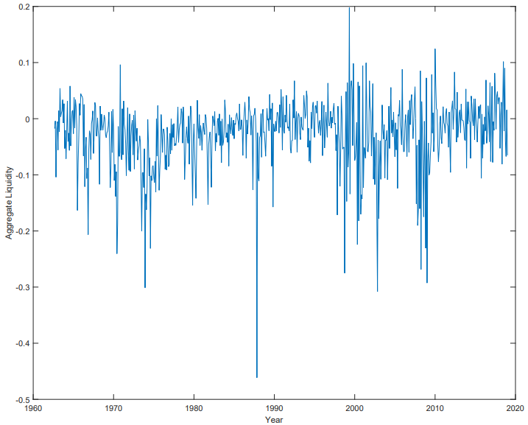Undoubtedly liquidity is a measure of representation of the state of the market. For instance, during a market crisis we can see that there is a drop-in liquidity in the market since transactions cannot be executed as easily as other times. We can observe this by looking at the following graph from Pastor and Stambaugh data which we include in our project:

We can identify some notable spikes in the graph of aggregate liquidity during world renowned market crashes such as:

* **Black Monday** in 1987 when there was a sudden market crush in October that lasted a day and the market recovered after 2 years.
* The **Dot-com Bubble** burst which happened in March of 2000 and would in fact take another 15 years for the market to regain its dotcom peak. It is

necessary here to comment on the rise of liquidity in the late 90’s since investors were affected by the rapid technological development and were investing irresponsibly in companies that were doomed to fail which eventually lead to the bubble burst in 2000.

* The **Great Recession** which lasted from 2007 to 2009 after the housing market crash and the bankruptcy of Lehman Brothers.

Consequently, if we take the above into consideration, we can argue that the returns of our stock portfolios would have also been affected by such market crashes.

Intuition supports the fact that after a market crash, we will see a violent change in our returns and liquidity factors. However, we need to contemplate also the role that the Federal Reserve System or central banks in general have in such circumstances. Central banks aim to stabilize the economic growth when a market crisis happens. One of the monetary policies that a central bank will conduct is, they will generally lower interest rates and thus lowering financing costs which will promote borrowing and investing. For example, after the Housing market crash the Fed lowered a key interest rate to essentially zero while also providing the banks with an amount of $7.7 trillion of emergency loans that the bank, a monetary policy also known as quantitative easing. These tools helped stabilize the liquidity in the market after the crisis.

In conclusion, our expected returns should be lower when we re-estimate the model out-of-sample (including the period from September 2008 to 2019). Although we expect to see a massive drop in our expected returns the following years and to continue decreasing, the Fed’s immediate actions and measures contained the catastrophe. The liquidity factors and hence our expected returns should be stabilized through the following years, but they will not reach the same height they had before the market crash since after 2008 banks adapted to a more restrictive policy for lending money.

In addition to this, to make sense of our results we can also consider a fundamental question: Is the real-world market efficient? Behavioral science teaches us that in the real world the market is somewhere between efficient and inefficient. Some **anomalies** that may interest us are:

* **Momentum** which refers to the speed of change of the prices of stocks.

(Jagadeesh and Titman, 1993) argue that the recent performance of our stocks and hence portfolios will continue over some time in the future.

* **Book-to-Market Effect** which refers to the comparison of the book market value of a company to the value of its stock.

(Fama and French 1993) believe that the stocks that have a higher book to market ratio will have a higher average return.

In conclusion, a major contributory factor to the portfolios returns is emotion. The market is emotionally driven, a lesson that the Black Monday 1987 teaches us but also a clear observation after the Housing market crash in 2008 people don’t trust the market as much as they used to and will be more risk averse in their preferences when investing.